Data Handling and Visualization (DSA06)
Name: Prasanna M Reg. No: 1925260244
Set 27: Patient Health Risk Analysis
Question 1. Using R, create a scatterplot matrix for Age, BMI, BP, and Cholesterol. Examine pairwise relationships to identify strong correlations, clusters, or potential risk patterns.
Program (R):
patients <- data.frame(Patient_ID = paste0("P", 1:5),
Age = c(25,40,55,35,60), BMI = c(22,28,30,26,32),
BP = c(120,135,145,130,150), Cholesterol = c(180,210,240,200,260))
pairs(patients[, c("Age","BMI","BP","Cholesterol")],
main = "Scatterplot Matrix of Patient Health Indicators", pch = 19, col = "steelblue")
round(cor(patients[, c("Age","BMI","BP","Cholesterol")]), 2)
Output:
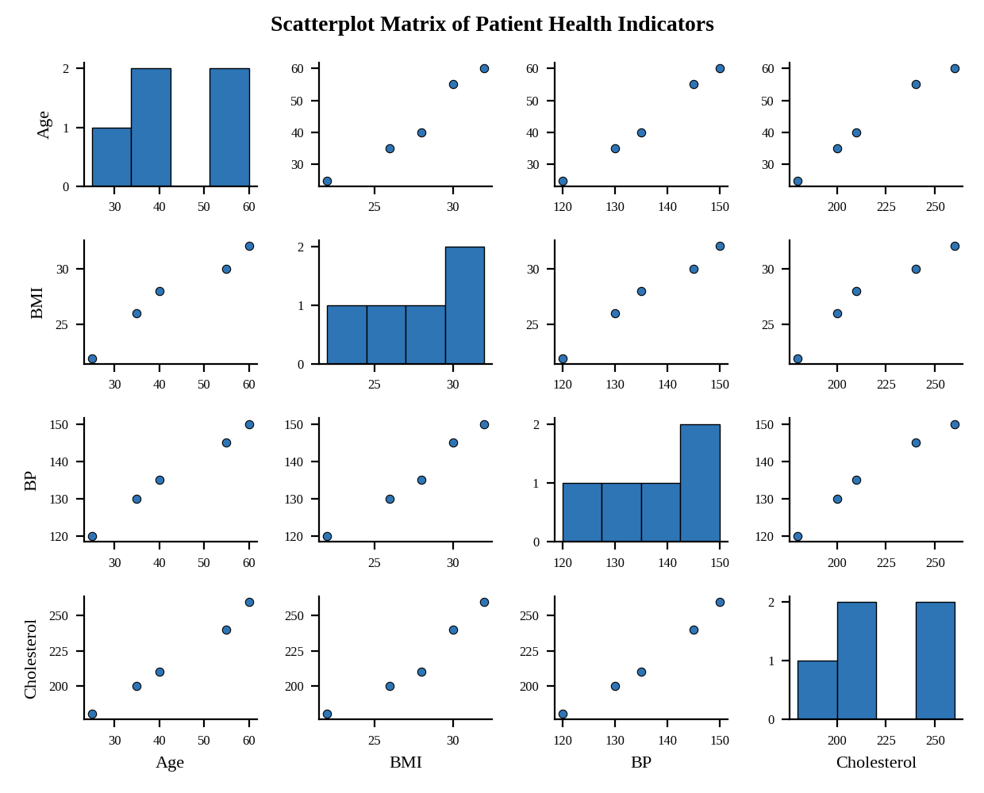
Interpretation:
Every pair of indicators moves together almost in a straight line, with correlations between 0.97 and 1.00 (for example Age and BP r = 1.00). Patients P1, P2 and P4 form a lower-value group, and P3 and P5 sit together at the high end of all four indicators, which marks them as the potential high-risk cluster. Strong correlation in five patients shows association only.

Question 2. Construct Q-Q plot and ECDF for Cholesterol levels to assess distribution behaviour. Comment on normality assumption and skewness.
Program (R):
par(mfrow = c(1, 2))
qqnorm(patients$Cholesterol, main = "Normal Q-Q Plot of Cholesterol", pch = 19, col = "steelblue")
qqline(patients$Cholesterol, col = "red")
plot(ecdf(patients$Cholesterol), main = "ECDF of Cholesterol",
xlab = "Cholesterol (mg/dL)", ylab = "Cumulative Probability", verticals = TRUE)
shapiro.test(patients$Cholesterol)
library(e1071); skewness(patients$Cholesterol)
Output:
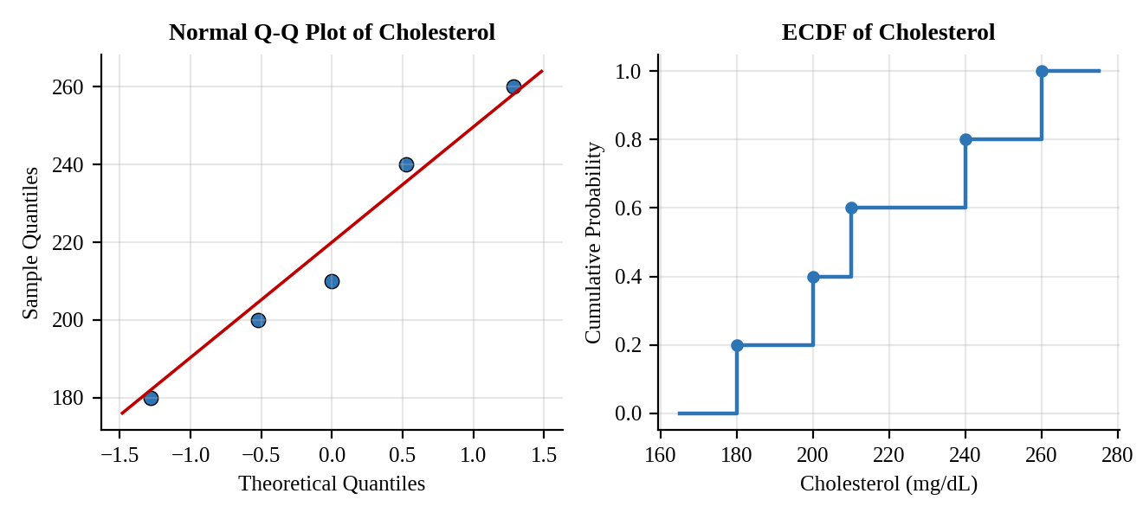
Interpretation:
The Q-Q points lie close to the reference line, and the ECDF rises smoothly from 180 to 260 mg/dL. The skewness is 0.20, a very slight positive (right) skew, and the Shapiro-Wilk test gives p = 0.86, so normality is not rejected. With five observations the test has little power, so the normality assumption is reasonable but weakly supported.

Question 3. Using R, create a bar chart showing the average values of each health indicator (Age, BMI, BP, Cholesterol). Include axis labels, a descriptive title, and distinct colors for each bar. How do these averages relate to general patient health risk?
Program (R):
avg <- data.frame(Indicator = c("Age (years)","BMI","BP (mmHg)","Cholesterol (mg/dL)"),
Average = colMeans(patients[, c("Age","BMI","BP","Cholesterol")]))
ggplot(avg, aes(x = Indicator, y = Average, fill = Indicator)) +
geom_col(colour = "black", width = 0.6) +
geom_text(aes(label = Average), vjust = -0.3) +
scale_fill_manual(values = c("#2E75B6","#ED7D31","#70AD47","#FFC000")) +
labs(title = "Average Value of Each Health Indicator", x = "Health Indicator", y = "Average Value") +
theme_minimal() + theme(legend.position = "none")
Output:
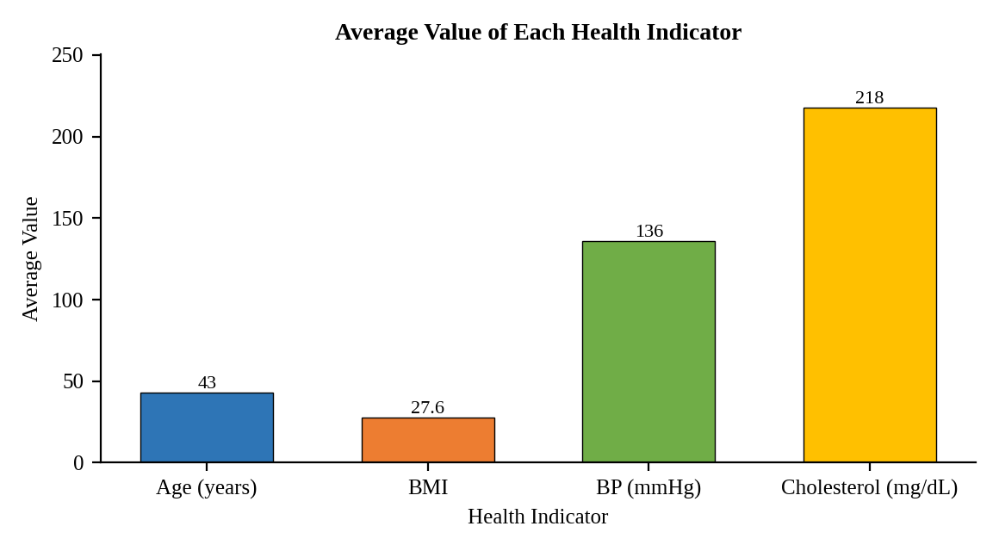
Interpretation:
The averages are Age 43 years, BMI 27.6, BP 136 mmHg and Cholesterol 218 mg/dL. The bars differ in height only because the units differ. Against common reference ranges, the average BMI is in the overweight range (25 to 29.9), the average blood pressure is in the stage 1 hypertension range (130 to 139 systolic) and the average cholesterol is borderline high (200 to 239). The group as a whole therefore carries a moderately raised cardiovascular risk.

Question 4. Create an interactive Tableau dashboard with a heatmap highlighting high-risk patients and an Age filter for exploring risk patterns. Include hover tooltips showing all health indicators. Analyze which patients are highest risk, how age affects risk, and how this dashboard can aid healthcare professionals in prioritizing care.
Procedure (Tableau):
1. Open Tableau, click Connect, choose Text file / Microsoft Excel, select "Patient_Health_Risk.csv" and open Sheet 1.
2. Create calculated fields for risk points, for example BMI Pts = IF [BMI] >= 30 THEN 2 ELSEIF [BMI] >= 25 THEN 1 ELSE 0 END; BP Pts (130 and 140) and Chol Pts (200 and 240) in the same way; Risk Score = [BMI Pts] + [BP Pts] + [Chol Pts].
3. Pivot BMI, BP and Cholesterol into "Indicator" and "Value" and compute the points for each. Heatmap: Rows = Patient_ID; Columns = Indicator; mark type = Square; Color = Risk points (red = high); Label = Value.
4. Drag Age, BMI, BP, Cholesterol and Risk Score to Tooltip so that hovering shows all indicators. Show the Age filter (Range) and apply it to the sheet.
5. Click New Dashboard, name it "Patient Risk Dashboard", set Size to Automatic and drag the sheets onto the canvas.
6. Select each chart and click the "Use as Filter" icon so that clicking a mark filters the other sheets; keep tooltips enabled.
7. Add a title to every sheet, adjust labels and colours, and save the workbook (File > Save As, .twbx).

Output:
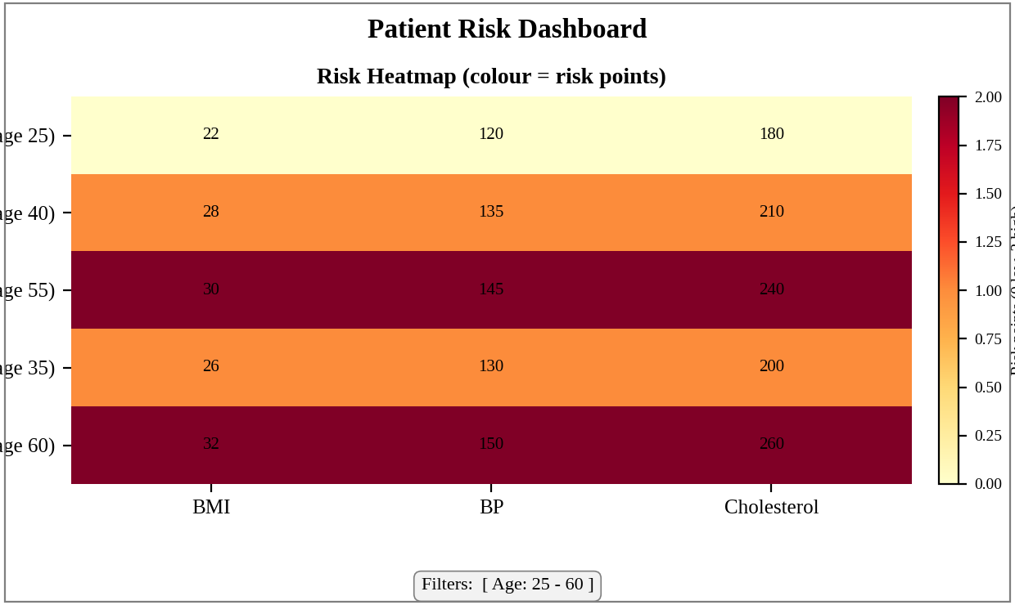
Dashboard layout (preview of the Tableau output). Risk points: BMI 25 and 30, BP 130 and 140, Cholesterol 200 and 240.
Interpretation:
Highest risk: P5 (age 60, BMI 32, BP 150, cholesterol 260) and P3 (age 55, BMI 30, BP 145, cholesterol 240) both score 6 of 6 and are all red. P2 and P4 are moderate (3 points) and P1 is low (0 points).
Risk rises with age: scores are 0, 3, 3, 6 and 6 for ages 25, 35, 40, 55 and 60 (r = 0.97). Clinicians can use the Age filter and the red cells to find patients who need urgent review, and the tooltip to see all indicators without opening a record, so care is prioritised for the oldest patients with several raised indicators.

